2023 Firearm Injury and Death Report
Jennifer Zuker

Summary
- The overall number of firearm related Emergency Departments (ED) visits remained steady in 2023
- There is a seasonal pattern each year with the first quarter being the lowest and the second/third quarter being the highest.
- In 2023, males were over 4 times more likely to have a firearm-related ED visit than females.
- The age groups with the highest ED visits in 2023 were 18-24 and 25-34 years old.
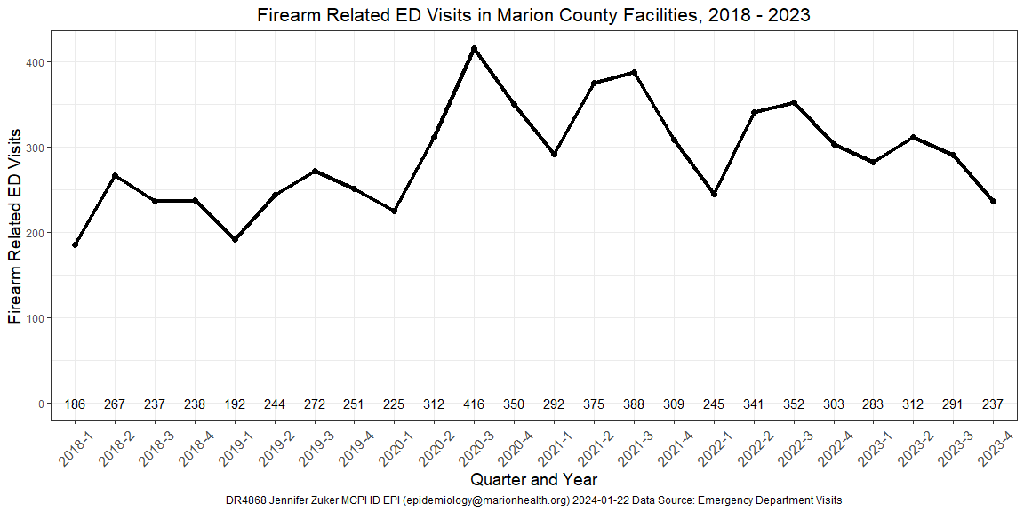

Emergency Department Visits by Age
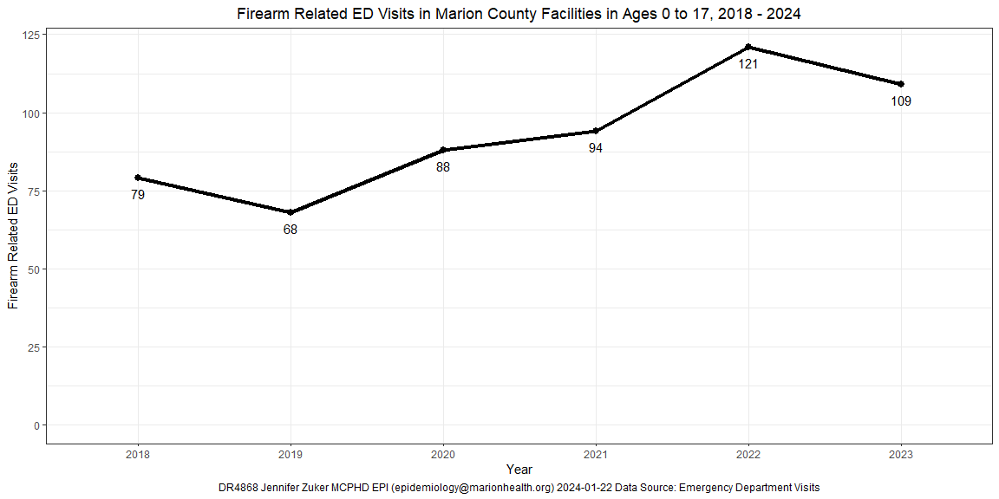
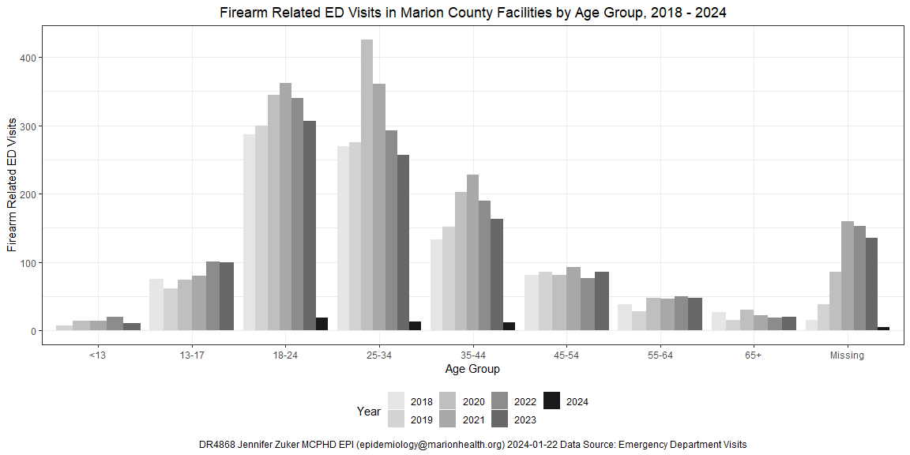

Emergency Department Visits by Race
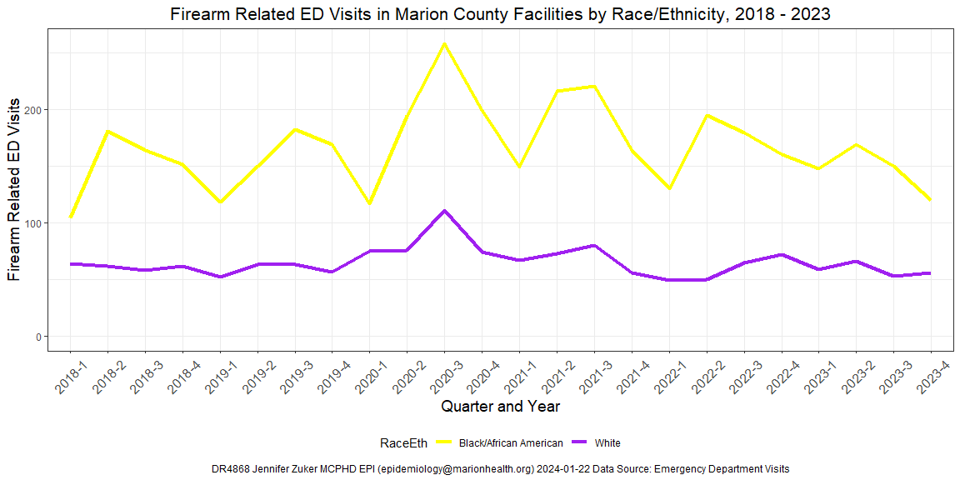

Emergency Department Visits by Sex
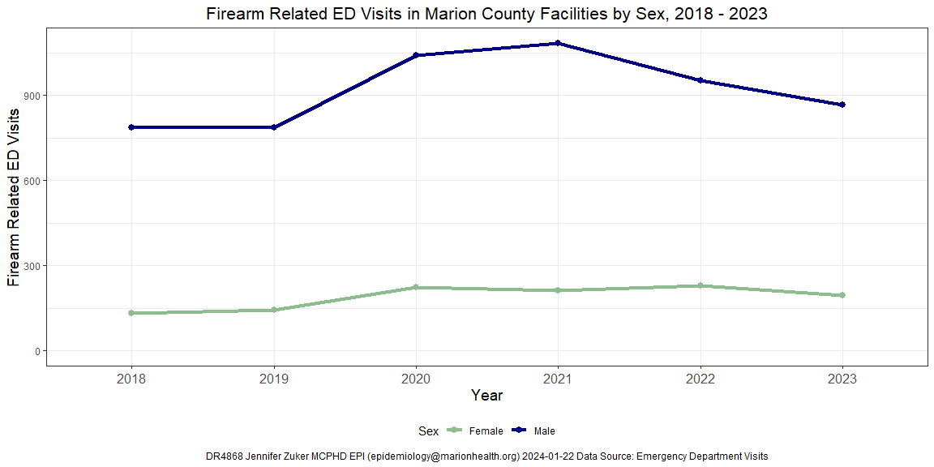

Homicides

Homicide Deaths by Year
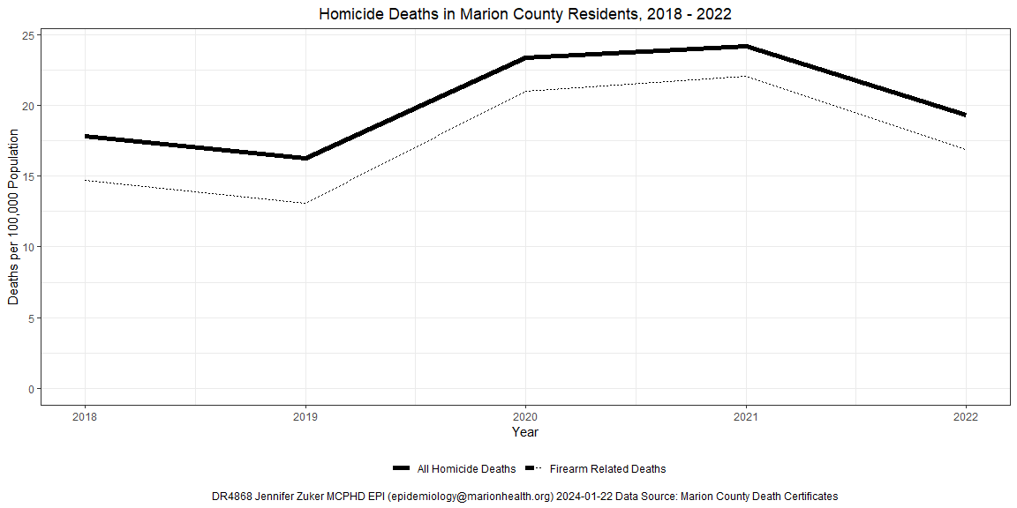

Homicide Deaths by Race/Ethnicity
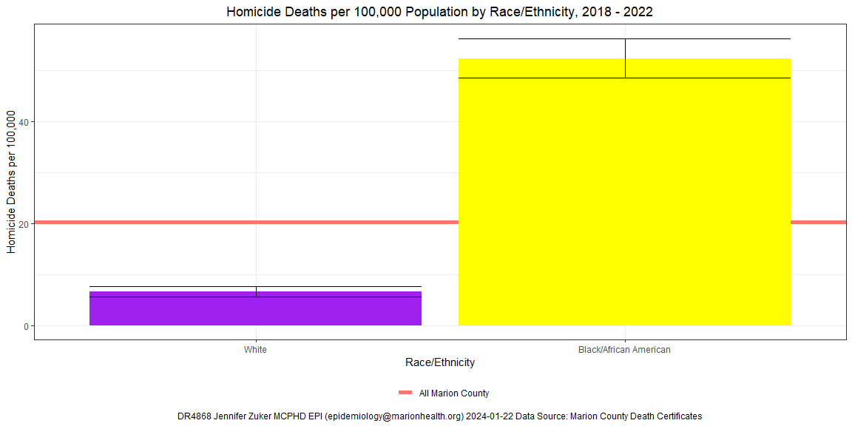

Homicide Deaths by Age
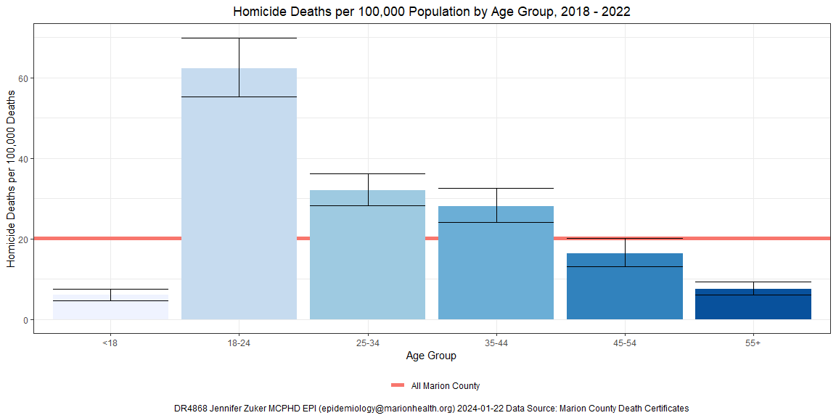

Homicide Deaths by Sex
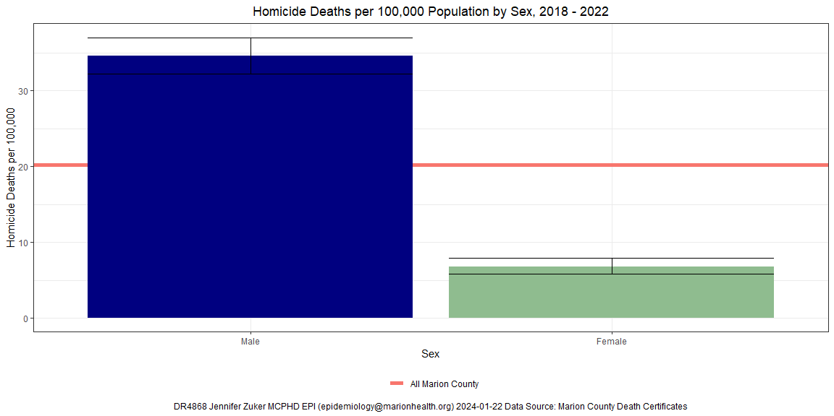

Firearm Related Deaths

Firearm Related Deaths by Year
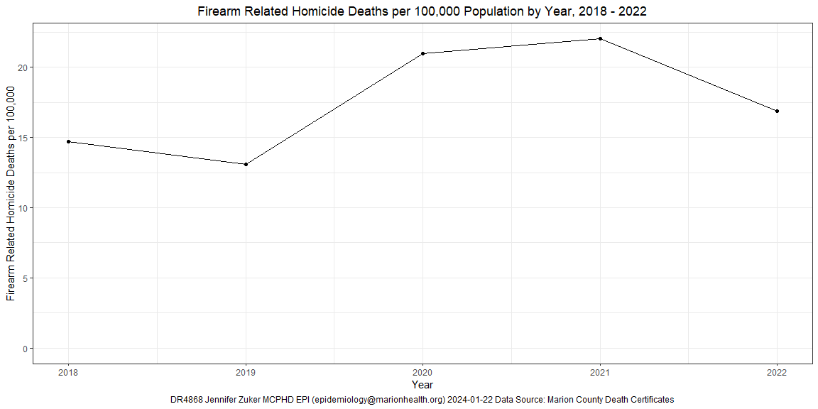

Firearm Deaths by Race/Ethnicity
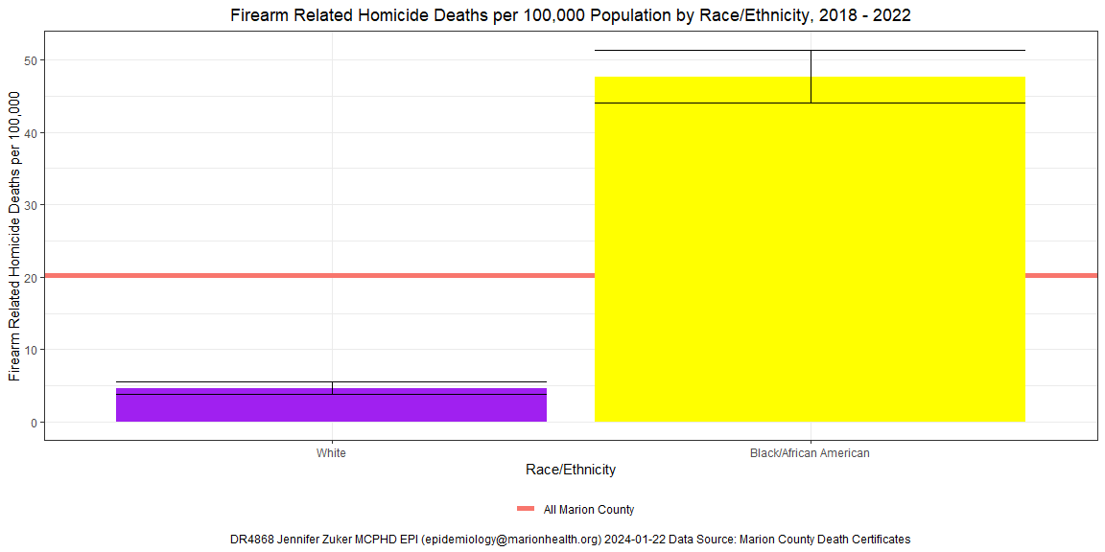

Firearm Deaths by Age
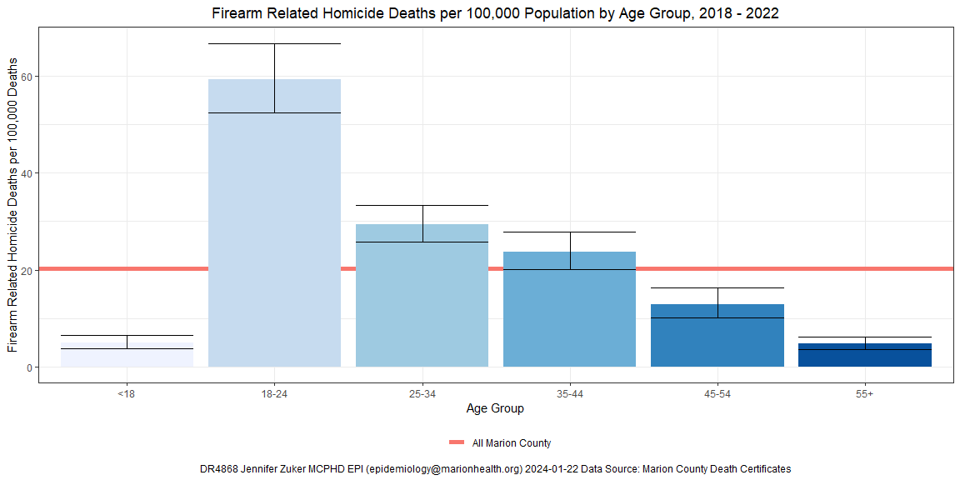

Firearm Deaths by Sex
